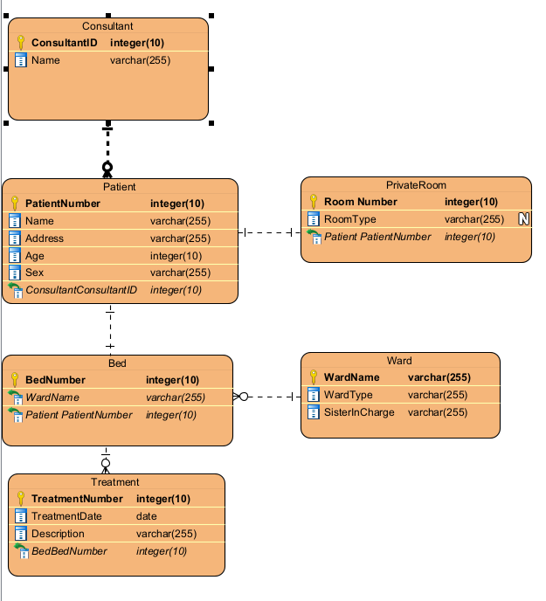

**Patient**

Patient (PatientNumber, Name, Address, Age, Sex, ConsultantConsultantID, RoomNumber, BedNumber)

PRIMARY KEY: PatientNumber

FOREIGN KEY (ConsultantConsultantID) REFERENCES Consultant(ConsultantID)

FOREIGN KEY (RoomNumber) REFERENCES PrivateRoom(RoomNumber)

FOREIGN KEY (BedNumber) REFERENCES Bed(BedNumber)

**PrivateRoom**

PrivateRoom (RoomNumber, RoomType, PatientPatientNumber)

PRIMARY KEY: RoomNumber

FOREIGN KEY (PatientPatientNumber) REFERENCES Patient(PatientNumber)

**Bed**

Bed (BedNumber, WardName, PatientPatientNumber)

PRIMARY KEY: BedNumber

FOREIGN KEY (WardName) REFERENCES Ward(WardName)

FOREIGN KEY (PatientPatientNumber) REFERENCES Patient(PatientNumber)

**Treatment**

Treatment (TreatmentNumber, TreatmentDate, Description, PatientPatientNumber)

PRIMARY KEY: TreatmentNumber

FOREIGN KEY (PatientPatientNumber) REFERENCES Patient(PatientNumber)